St. Petersburg: details about logistics and some practical information

- There are 3 possibilities to get to your hotel

a) At the airport take a taxi, information here: https://www.pulkovoairport.ru/en/transport/taxi/

Price 1000 -1200 Rubles (1 euro = 62-64 rubles).

b) The cheaper way is the airport transfer service. The driver will meet you at your arrival point with a signboard and take you directly to the hotel. To order a transfer click here.

c) For those who likes adventures (not dangerous but far and inconvenient) and has not much luggage: bus + metro: When you exit the Pulkovo terminal, you will see a bus stop near the Arrival hall. The information about busses and prices: https://www.pulkovoairport.ru/en/transport/bus/
They all go to Moskovskaya metro station. Take the metro to the metro station which is close to your hotel.

3. The conference venue is ul. Marata, 82. An inconspicuous building:-). The next metro stations are Pushkinskaya (red line) and Zvenigorodskaya (violet line):
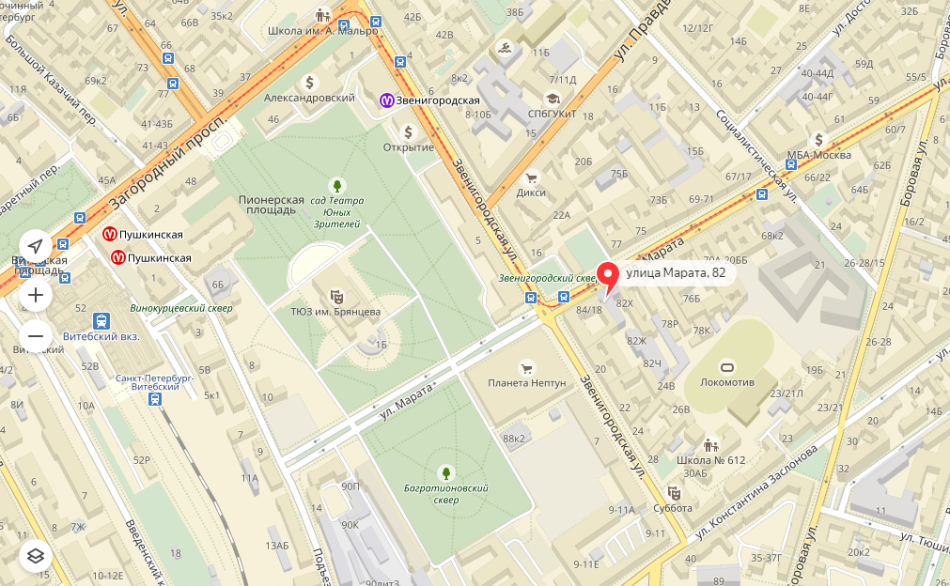

Practical information

1. Money
The official currency is the Rouble (RUB), which is divided into 100 kopeks. Most major credit cards, like Visa and Mastercard are accepted in the larger hotels and at places that deal with foreign tourists. Currency can be changed at banks, currency exchange booths and hotels. Travellers cheques are difficult and expensive to cash, but if necessary it is advised to take them in US Dollars or Euro. ATMs are widely available. It is hard to get roubles outside Russia, so I can advise to take good condition US dollars or Euro notes to change once here (it is illegal to pay for goods or services in hard currency).

2. Getting around St. Petersburg by metro, public transport, taxi

St. Petersburg Metro
It is the deepest subway in the world! (http://www.metro.spb.ru/en/) It is not difficult to use it. As you can see on the metro map (http://www.metro.spb.ru/map1/route.html), there are just 5 lines. Metro entrances are marked with a blue letter "M" on top.
The metro is opened from 5.45 a.m. to 0.15 a.m. Normally, trains arrive every 2-4 minutes.

Orientation
There are metro schemes in every car and at the stations. When you're on the station and want to find out the direction you need just look up there're signs hanging on the ceiling - a list of stations in every direction. If you need to find a way out of the metro also look up to see where the exit to the city is ("Exit to the city) and to which street (ulitsa). If you need to find a pass to another station, also look up for signs.
Tickets
The metro has no special zones - all metro is one zone, and there's no time limit for using your ticket. So, you can buy a token ("zheton") for 45 roubles for one trip (at every station) and spend as much time inside as you like. Or you can buy one of many possible travel passes, it’s cheaper? Information about prices here: http://www.metro.spb.ru/en/pricetickets.html
Zhetons and travel passes you can buy at the ticket book (russ. касса).

Buses, Trolleys and Trams
They don't go on the schedule, and the average waiting time can be from 5-10 minutes to 40 minutes in the evenings. The hours of work are from 6:00 until 24:00. The bus stops are yellow plates marked with "A" signs, trolleys' and trams - white plates with "T". A ticket for one trip costs 40 roubles. You can buy tickets onboard from the conductor. The price is fixed and does not depend on the duration or distance of your trip.

Marshrutka
...is a minibus. They usually go the same route as the buses or trolleys. If you see an approaching shuttle, just wave it down like a taxi. You must pay for a trip from 40 to 45 roubles to the driver when you come in. When you are near your stop just say aloud to the driver where to stop. He will understand if you just say "Stop!" or "Ostano`vite po`zhaluista" (stop please).

3. Weather

Fortunately, July is a very good time to visit St. Petersburg because of sunny days and last white nights. You must think of comfortable shoes, you will certainly walk much ;-).

To be on the safe side please ensure that you have warm clothes in your luggage, the weather in St. Petersburg is very changeable.

All necessary information you can find here: http://www.saint-petersburg.com

